

JK LAKSHMIPAT UNIVERSITY

DIGITAL CIRCUIT AND SYSTEMS  
(EE1120)

Activity 08

4 – Bit Adder using VHDL language.

Date : 5th March 2024

Name : Bobby Sharma

Roll no. = 2023BTECH023

# AIM: Design and Simulation of 4 bit Full Adder using single bit FA (Structural Modelling) using VHDL language using Xilinx ISE Tool.

SOFTWARE REQUIRED: Xilinx ISE tool in your device.

THEORY:

In binary addition, you add each pair of corresponding bits from the two binary numbers, starting from the least significant bit (LSB). If the sum of two bits is 0 or 1, it directly goes into the result. If the sum is 2, it is represented as '10' in binary, and a carry is generated. If the sum is 3, it is represented as '11' in binary, and again, a carry is generated.

SCCHEMATIC DIAGRAM:

A 4-bit adder is constructed using four full adders connected in series. Each full adder takes three inputs: A, B, and a carry-in (Cin) from the previous stage. The outputs are a sum (S) and a carry-out (Cout).

The carry-out from each stage is connected to the carry-in of the next stage. The schematic diagram of a 4-bit adder illustrates how the full adders are interconnected, with inputs and outputs properly arranged. Each full adder block receives inputs A, B, and the carry-in (Cin), and produces a sum (S) and a carry-out (Cout).

The final output is a 4-bit sum and a carry-out is represented in figure 1.

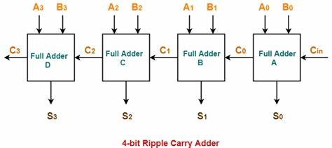

Figure 1

Overflow occurs when the sum of two positive numbers is too large to be represented with the given number of bits. In a 4-bit adder, overflow can be detected by checking the carry-out from the most significant bit (MSB).

OBSERVATION: The observed outputs of all the basic gates are as follows:

* FULL ADDER:

VHDL Code: RTL Diagram:

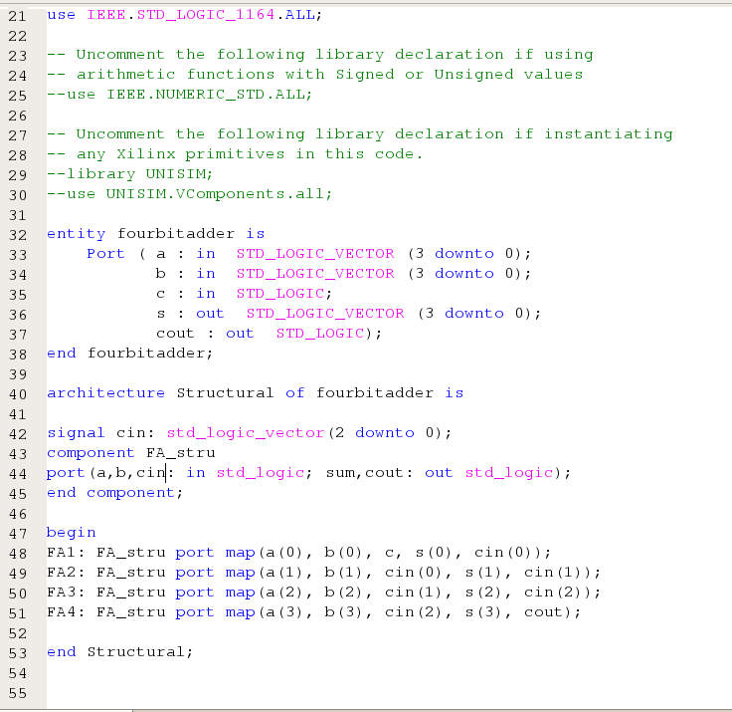 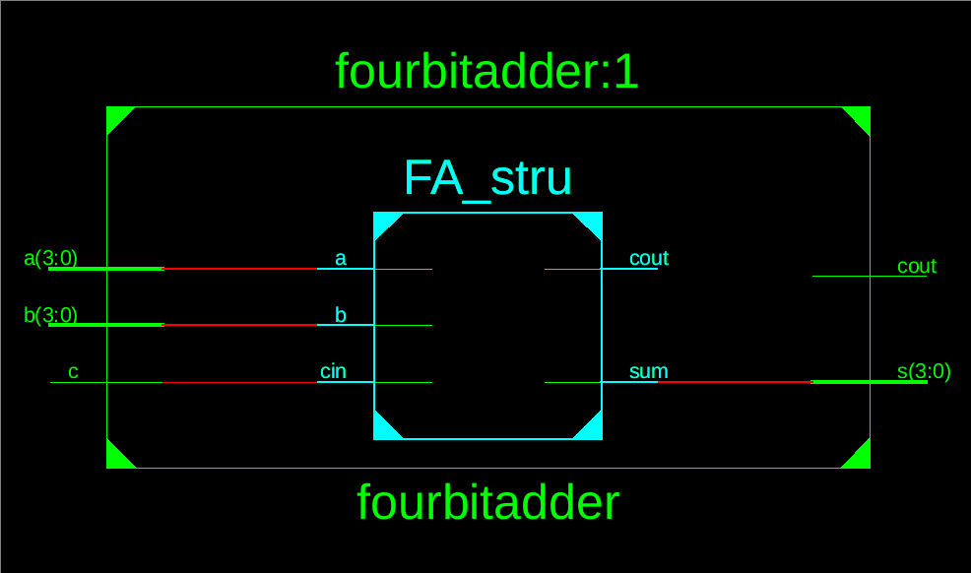

Figure 2 Figure 3

Test Bench Code:

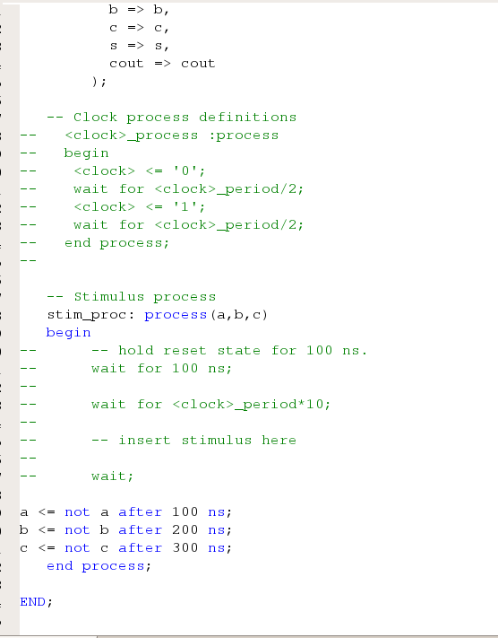

Figure 4

Waveform:

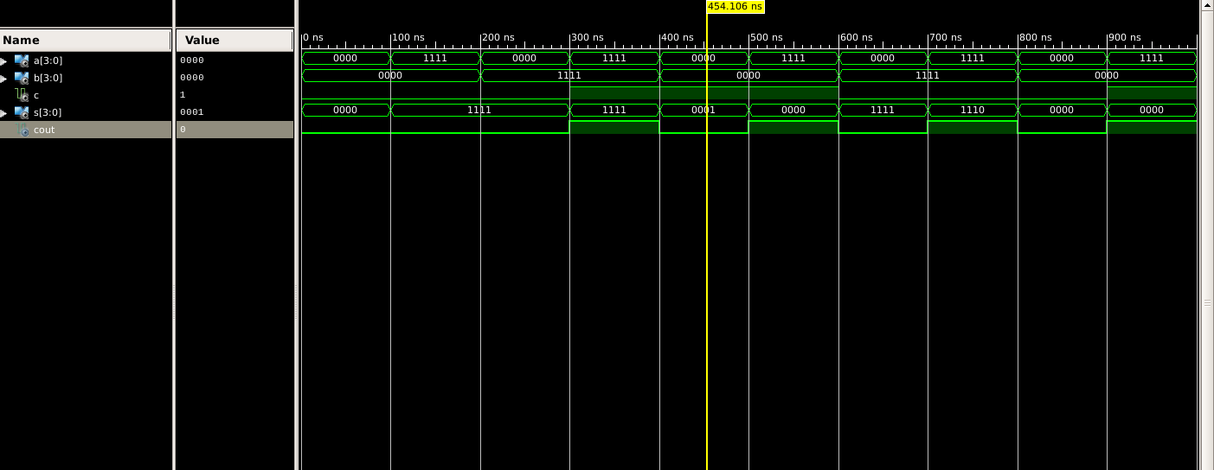

Figure 5

Here the yellow line in figure 5 represents the input (a=0000, b=0000 and carry(in)=1) and output(sum = 0001 and carry(out) = 0). In which we can see the change of input signals of and b after every 100, 200 and 300 nano seconds respectively.

The truth table for a 4-bit adder lists all possible combinations of inputs (A, B, and Cin) and the corresponding outputs (Sum and Cout).

|  |  |  |  |  |
| --- | --- | --- | --- | --- |
| A | B | Carry(in) | Sum | Carry(out) |
| 0 | 0 | 0 | 0 | 0 |
| 0 | 0 | 1 | 1 | 0 |
| 0 | 1 | 0 | 1 | 0 |
| 0 | 1 | 1 | 0 | 1 |
| 1 | 0 | 0 | 1 | 0 |
| 1 | 0 | 1 | 0 | 1 |
| 1 | 1 | 0 | 0 | 1 |
| 1 | 1 | 1 | 1 | 1 |

Table 1

# RESULT: We have concluded the truth table of full adder using VHDL language in Xilinx ISE Tool.

APPLICATION IN DAILY LIFE:

A 4-bit adder is a digital circuit that performs the addition of two 4-bit binary numbers. While you may not directly encounter 4-bit adders in your daily life, they play a crucial role in various electronic devices and systems. Here are some applications where 4-bit adders, and similar circuits, are used:

* Microprocessors and Microcontrollers: 4-bit adders are essential components in the arithmetic logic unit (ALU) of microprocessors and microcontrollers. ALUs perform arithmetic and logic operations, including addition, subtraction, AND, OR, XOR, etc.
* Calculators: The arithmetic operations in electronic calculators involve the use of adders. Although modern calculators use more advanced architectures, the basic principle of binary addition is still applicable.
* Digital Signal Processing (DSP): In audio and image processing applications, 4-bit adders are used in digital signal processors for tasks such as filtering, convolution, and other mathematical operations.
* Memory Addressing: In computer memory systems, addressing involves the addition of binary numbers to access specific memory locations. 4-bit adders may be used in the memory addressing circuits.
* Data Communication: In data communication systems, 4-bit adders are used for error detection and correction, encoding, and decoding processes.
* Control Systems: Digital control systems often use arithmetic operations for processing feedback and adjusting control signals. 4-bit adders can be part of the control circuitry in such systems.